CAWOS Little Owl Callback Survey

Dear Surveyor,
Thank you for joining the Little Owl Callback survey. It’s much appreciated.
It is noticeable that the Little Owl has declined in Cheshire and Wirral over the years, nests that were productive I the last decade have been lost. Therefore, it is important to understand the current population of owls in the county and compare with historical atlas data to look in detail at the losses in numbers and distribution across their previous distribution.
This survey is a pilot, which is designed to fine tune the methodology which has been extracted from the standard playback surveys undertaken in Belgium and Netherlands.
As mentioned previously, it is note that the Little Owl population is suffering a decline in England and Wales, this is indicated in the graph
Thanks to the BTO for allowing me to use their data to illustrate this.
I hope that with this survey, we can begin the road to conserve these enchanting owls in our landscape and safeguard them for future generations.
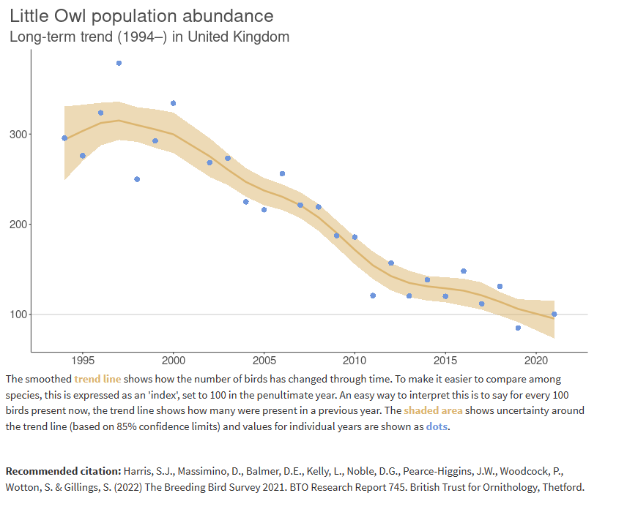
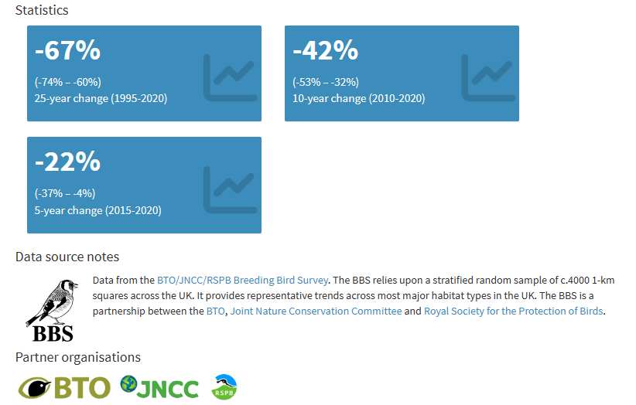

Causes of change
There is little evidence available from the UK but studies from Europe suggest that the main demographic driver of declines in Little Owl is falling rates of juvenile survival. Circumstantial evidence suggests that this may be occurring due to loss of habitat and changes in farming practices.

Further information on causes of change
Modelling suggests that climate change may have had a negative impact on the long-term trend for this species Pearce-Higgins & Crick. Demographic trends, although based on a low sample size as few records are available, suggest that the decline is unlikely to be linked to failed nesting attempts, as all measures are unchanged or have increased, including the number of fledglings per breeding attempt.
There is very little evidence available from the UK regarding causes of the population decline. However, evidence from mainland Europe suggests that population changes are driven mainly by changes in survival. Le Gouar et al. analysed 35 years of ringing data from the Netherlands and found that juvenile survival rates decreased with time and that years when the population declined were associated with low juvenile survival.
More than 60% of the variation in juvenile survival was explained by the increase in road traffic intensity or in average spring temperature.
However, they state that these correlations reflect a gradual decrease in juvenile survival coinciding with long-term global change, rather than direct causal effects. The regular occurrence of years with poor adult survival (dry, cold years) was also important.
My experience in Cheshire and Wirral from nest recording and ringing suggests a similar trend, by participating in the survey you are helping inform the baseline data, which we can use plan further studies and conservation initiatives.

I hope thar you enjoy doing the survey, the purpose of this pilot is to fine tune the methodology for a larger scale survey in 2027, the results of which will be used to inform the CAWOS and BTO breeding bird atlas surveys.
Please select a survey point of your choice in habitat that offers potential little owl habitat.
Next year we will be more selective we will be targeting squares that recorded breeding Little Owls during the CAWOS Atlas, hopefully this will provide data on distribution and status.
If you go to the CAWOS website www.cawos.org you will notice a link to the survey, which also provides copies of all documents supplied in the pack. You can also input your data if you wish, or you can post or email it to me to input on your behalf.

On behalf of CAWOS Thank you for participating.

Roy S Leigh
